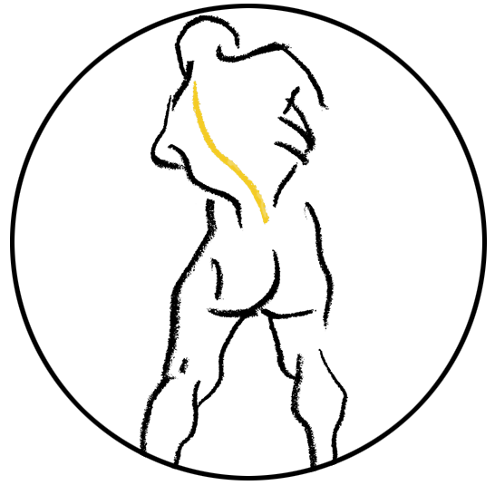

THESIS COPYRIGHT PERMISSION FORM

Title(s) of the Image(s): Terese Winslow LLC owns the copyright to the following image(s):

Title(s) of illustration(s):

Description of the Work: Terese Winslow LLC hereby grants permission to reproduce the above image(s) for use in the work specified:

Thesis title:

University:

Digital Object Identifier (DOI) and Journal ISSN, if available:

License Granted: Terese Winslow LLC hereby grants limited, non-exclusive worldwide print and electronic rights only for use in the Work specified. Terese Winslow LLC grants such rights “AS IS” without representation or warranty of any kind and shall have no liability in connection with such license.

Restrictions: Reproduction for use in any other work, derivative works, or by any third party by manual or electronic methods is prohibited. Ownership of original artwork, copyright, and all rights not specifically transferred herein remain the exclusive property of Terese Winslow LLC. Additional license(s) are required for ancillary usage(s).

Credit must be placed adjacent to the image(s) in the following format:

For the National Cancer Institute © (copyright year) Terese Winslow LLC, U.S. Govt. has certain rights

Permission granted to:
Name:
Mailing address:

Email address:
Phone number:

Signature Date Name

Signature Date
Terese Winslow, CMI, Member

Terese Winslow LLC, Medical Illustration
714 South Fairfax Street, Alexandria, Virginia 22314
(703) 836-9121
terese@teresewinslow.com
www.teresewinslow.com

